Proposal for EBI (Education Bridge Initiative) RFP:

EduScope
  - Decision-support system for education planning in fragile contexts

Context
EBI operates in 12 conflict-affected countries across Sub-Saharan Africa, the Middle East, and South-East Asia. Its field experts have long supported schools and education staff, building deep contextual knowledge of local infrastructures, organisations, and communities. This expertise, combined with strong local networks, is critical in crisis contexts and must be leveraged to ensure continuity of quality education for students, regardless of conditions or accessibility challenges.
EBI’s current planning and prioritisation relies heavily on field team expertise, but information from the field often reaches headquarters unevenly, limiting the ability to maintain a real-time, comprehensive overview of education infrastructure across regions. As a result, responses are often reactive, led by the nearest available teams during crises.
EBI has already begun exploring data-driven approaches through an initial analysis mapping schools against population distribution, revealing important mismatches between school locations and where school-age populations are concentrated. This confirmed the value of open data for planning.
Building on this, the next step is to go beyond supply-demand mapping and incorporate access as a key dimension. In conflict-affected settings, it is not enough to know where schools are located if they are not safely reachable. Integrating road networks and conflict data allows for a more complete understanding of accessibility, including how routes and access conditions change over time.
The core challenge is therefore to combine these layers of information into a single, coherent decision-support system that integrates geospatial analysis with the lived experience and knowledge of field teams.

Approach
The system combines real-time field inputs, geospatial analysis, and AI-generated insights into a single decision-support workflow.
This proposal introduces a lightweight, data-driven decision-support system designed to help EBI prioritise interventions and maintain education access in conflict-affected regions. The core angle of the project is to move from static school mapping to dynamic access analysis, enabling EBI to understand not only where schools are located, but whether and how they remain reachable for children as conflict dynamics evolve.
The approach combines geospatial analysis, real-time field inputs, and AI-supported insights into a single, integrated workflow that complements the knowledge of field teams rather than replacing it. By leveraging open data sources and simple, adaptable tools, the system is designed to be scalable across different country contexts and usable by non-technical staff.

Proposed activities
- Data integration and spatial analysis
The first step is to collect and integrate open geospatial datasets, including:
- school locations (primary and secondary)
- population distribution
- conflict events
- road networks
These datasets are combined to create a spatial overview of where education demand, infrastructure, and risk intersect, making it possible to identify areas where access to education is most constrained.
- Development of an interactive geospatial tool
At the core of the project is a web-based interactive map that allows users to explore these datasets together.
The map:
- visualises population density, schools, conflict events, and infrastructure
- allows users to compare demand and supply across space
- supports simple scenario analysis (for example, understanding how road disruptions or localised conflict affect access to schools)
The interface is intentionally simple and designed for non-technical users, with a clear visual hierarchy that helps guide interpretation.
3. Field alert mechanism
To improve information flows, the project includes a lightweight system through which field teams can report key events, such as:
- emerging risks
- new clashes
- road closures
- school closures
These alerts are integrated directly into the map, allowing headquarters to have a more up-to-date and structured view of the situation, while keeping field teams at the centre of the process.
5. AI-supported knowledge layer
The project introduces an AI-supported component that processes existing reports and past crisis documentation.
The goal is not to create a chatbot, but to:
- structure qualitative information
- extract recurring patterns
- make insights easier to access and use
This helps EBI move from reactive responses to more anticipatory decision-making, building on lessons learned from past situations.
6. Bootcamp for field workers
The solution is designed to be user-friendly and accessible; however, a short training phase is key to ensure adoption. Rather than introducing new workflows, the system builds on information that field teams already use daily, translating it into a shared and structured decision-support framework.
Field staff will be able to submit alerts through a simple mobile-friendly interface designed to work in low-connectivity environments. Where connectivity is limited, inputs can be stored offline and synchronised once a connection is available.
This component ensures that the system is not only technically functional, but also actively used and integrated into EBI’s operational workflows.

The solution in detail
A three-layer solution combined with a learn-by-doing bootcamp that will enable field experts to use the tool and to test it.
The solution:
- Layer 1: At the core of the project is an interactive geospatial tool that maps school locations against population distribution and road networks, enriched with conflict event data. This allows EBI to identify areas where high concentrations of people face limited or deteriorating access to education. The tool includes conflict history as well as live updates (30 mins) on ongoing conflict events with one or more casualties so that it is possible to know which routes are blocked and which alternative routes are available to reach an education facility.
Here you can look at a similar map developed for a previous project in the north-eastern area of Borno State in Nigeria. When you open the map, you can turn on different filters from the sidebar and click on schools in order to have a detailed situation of the road networks and the past and present conflict events in the area: Geospatial Decision-Support Tool for Education Access - Borno State

- Layer 2: To address the current fragmentation of information flows, the project includes a lightweight field alert mechanism, through which local staff can report incidents such as school closures, unsafe routes, or population movements. These inputs are visualised directly on the map, strengthening real-time situational awareness at headquarters while preserving the central role of field expertise.

- Layer 3: Finally, the system incorporates an AI-supported knowledge layer that processes existing field reports and past crisis documentation. By transforming qualitative information into structured insights, this component helps identify recurring patterns in how conflict impacts education access and supports more anticipatory decision-making. These insights complement the geospatial analysis, enabling EBI to prioritise interventions based not only on current conditions but also on lessons learned from similar contexts. This layer impacts on scalability because it collects knowledge from all field work teams over the different countries and regions where the organization is and has been active over the years.

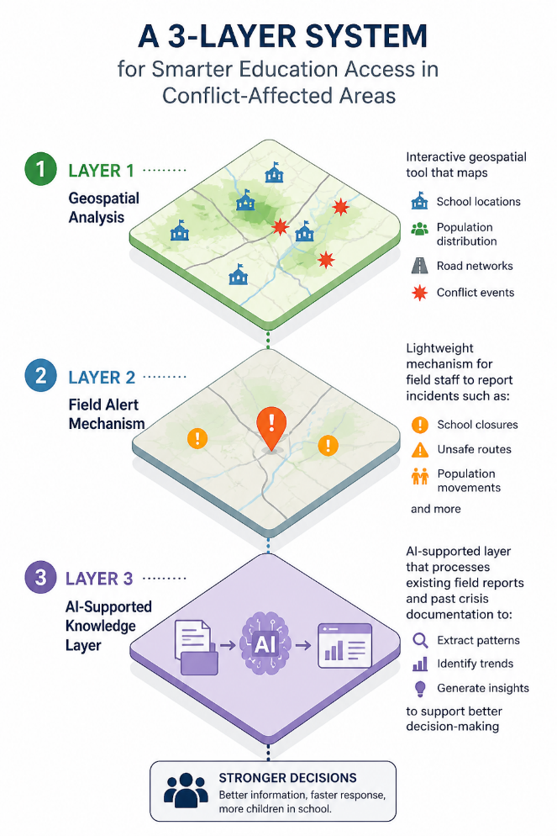
Together, these components form an adaptable approach that strengthens EBI’s ability to plan, prioritise, but also respond effectively in rapidly changing environments.

Deliverables:
Deliverable 1
Single-entry interface platform where users can explore geospatial data and immediately access AI-generated insights that translate complex field information into actionable prioritisation signals. Rather than a conversational chatbot, the AI is embedded as a structured decision-support layer to ensure clarity, reliability, and usability for non-technical users and it is always paired with the map data.
Deliverable 2
Comprehensive training programme to be delivered to:
- Field officers
- Local coordinators and partners
- Selected HQ focal points (for coordination and oversight)
Format:
The training is designed to be lightweight, modular, and adaptable:
- 1 initial onboarding session (remote or in-person depending on context)
- 2 practical hands-on sessions
- Optional refresher session after 4–6 weeks of use
Where connectivity is limited, materials are designed to be accessible offline.
Learning Approach:
The training follows a learning-by-doing approach, based on:
- real scenarios from EBI contexts
- interactive map exploration
- simple exercises using actual field cases
- peer-to-peer exchange of local knowledge
This approach is designed to evolve alongside EBI: a lightweight yet scalable tool that grows through daily use and strengthens the central role of field teams as key actors within the information system. The ambition is to build, together, a more shared, up-to-date, and action-oriented decision-making foundation for field operations.
Link to github repository

